# ESL Flashcard system.

## Overview (Big heading):

The Red Panthers project idea is to create an English as a Second Language (ESL) flashcard system for teaching basic English nouns to children learning English. The application will be created using Unity3D alongside Microsoft Visual Studio and written in C#. This software will teach basic English to children using a flashcard system with mini-games to keep the children interested and engaged through the process.

## Motivation (Big heading):

People worldwide consider English to be the most valuable language to learn as a second language [1]. Research has predicted that the market for learning English as a second language will grow 7.1% and is expecting to hit the $54.8 billion mark by 2025 [2]. Our motivation is to tap into this growing market and help children learn some English in areas of the world that do not have access to native English speakers to teach them, such as Vietnam where there is currently a lack of English teachers available [3].

## Description (Big heading):

### Features (small heading):

The ESL flashcard system will start with these features, with the possibility to expand and add more features later as needed:

* main menu
* collection of stock flashcards (showing a picture and the English noun below it)
* flashcard selection screen to choose the appropriate flashcards
* a system which allows users to add their own flashcards and associated voice recording
* ‘Click the correct card’ mini-game
* ‘Memory’ mini-game

Program Flow Overview (small heading):

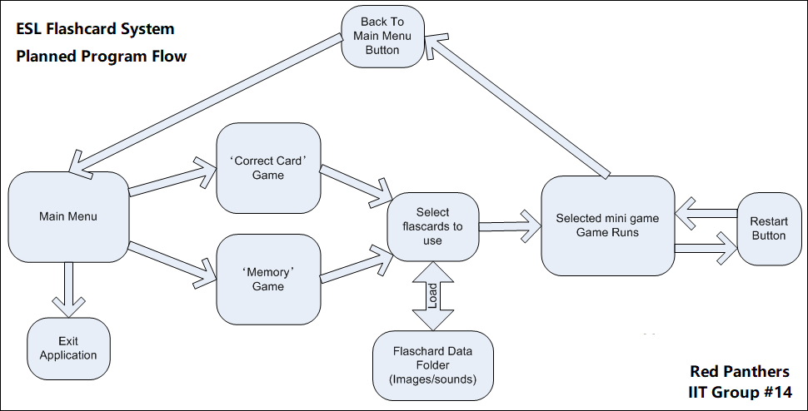

### Main Menu (small heading):

The main menu will consist of three buttons:

* ‘Correct Card Game’
* ‘Memory Game’
* ‘Exit Application’

Clicking either of the game buttons will proceed to load up the selected mini-game, whereas the exit button will simply exit the application. The application will have an appropriate background image and a simple music loop.

### Flashcard Selection (small heading):

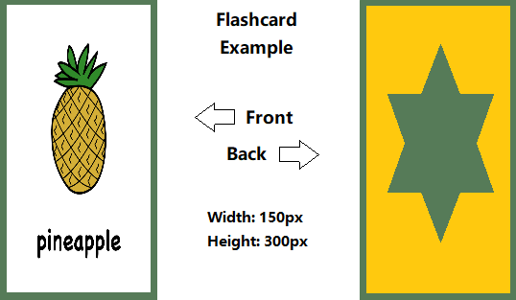The flashcard selection will have a large pane that will consist of all flashcards currently in the flashcard data folder. Each flashcard will have an audio file (.mp3) to show how the word is pronounced.

The user will have to select six flashcards. As the user clicks flashcards, they will turn green. Once the user has choosen six flashcards, they will continue to the game they previously selected.

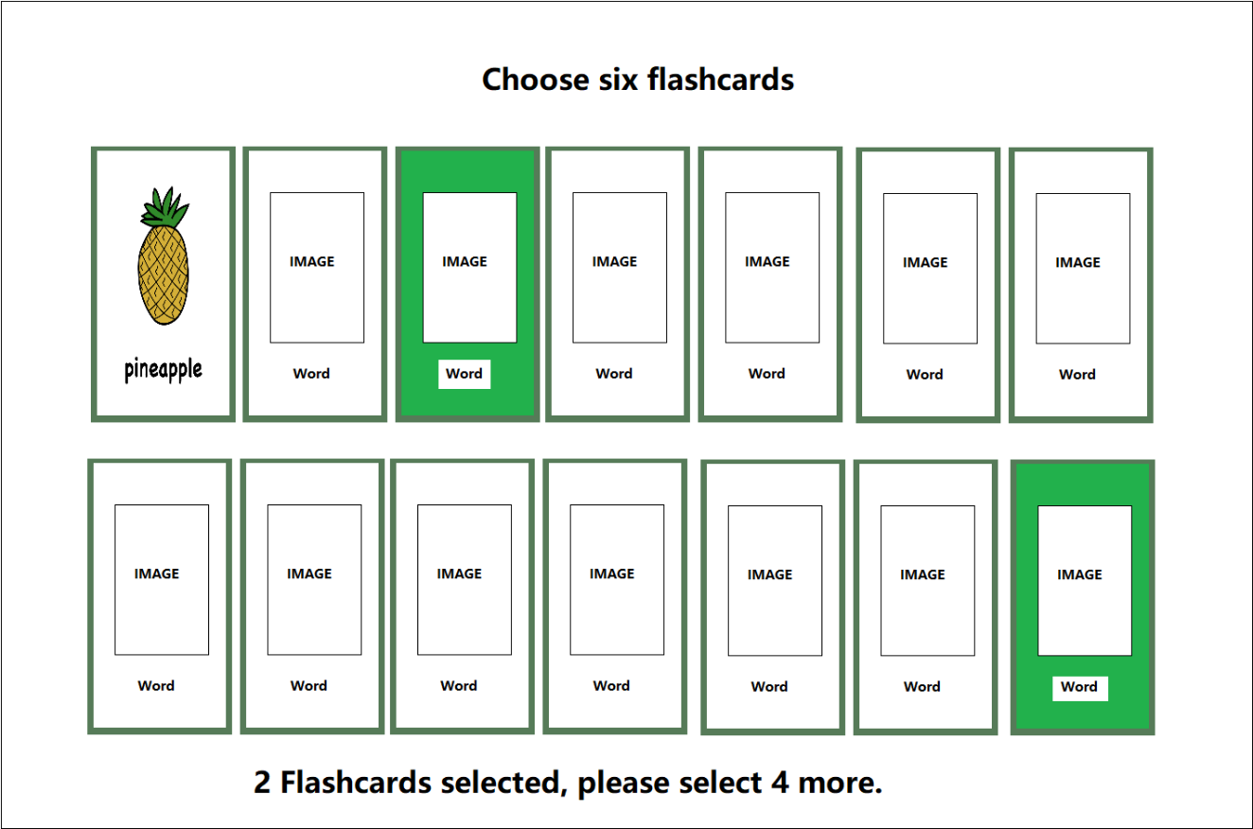

### ‘Correct Card Game’ (small heading):

A row of six flashcards will be displayed face up. The application pronounces one of the cards and the user then has 10 seconds to click on the matching flashcard. The user gets one point for a correct answer, or one point deducted for a wrong answer. The round will end when the application has finished reading all the flashcards. The game will not repeat the same flashcard twice.

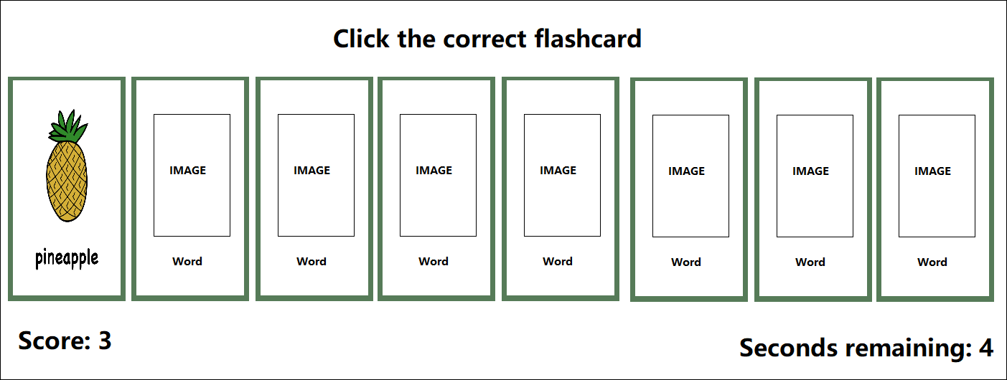

### ‘Memory Game’ (small heading):

A grid of flashcards is displayed, which is each of the six flashcards loaded twice, then distributed randomly on the screen. The flashcards are face down. The user will then click flashcards in pairs, looking for matches. As the card turns over, the audio plays. The user gets a point every time they fail to reveal a matching pair. The round ends when the user has matched all the pairs. The aim is to do it in the least number of moves, i.e. the lowest score.

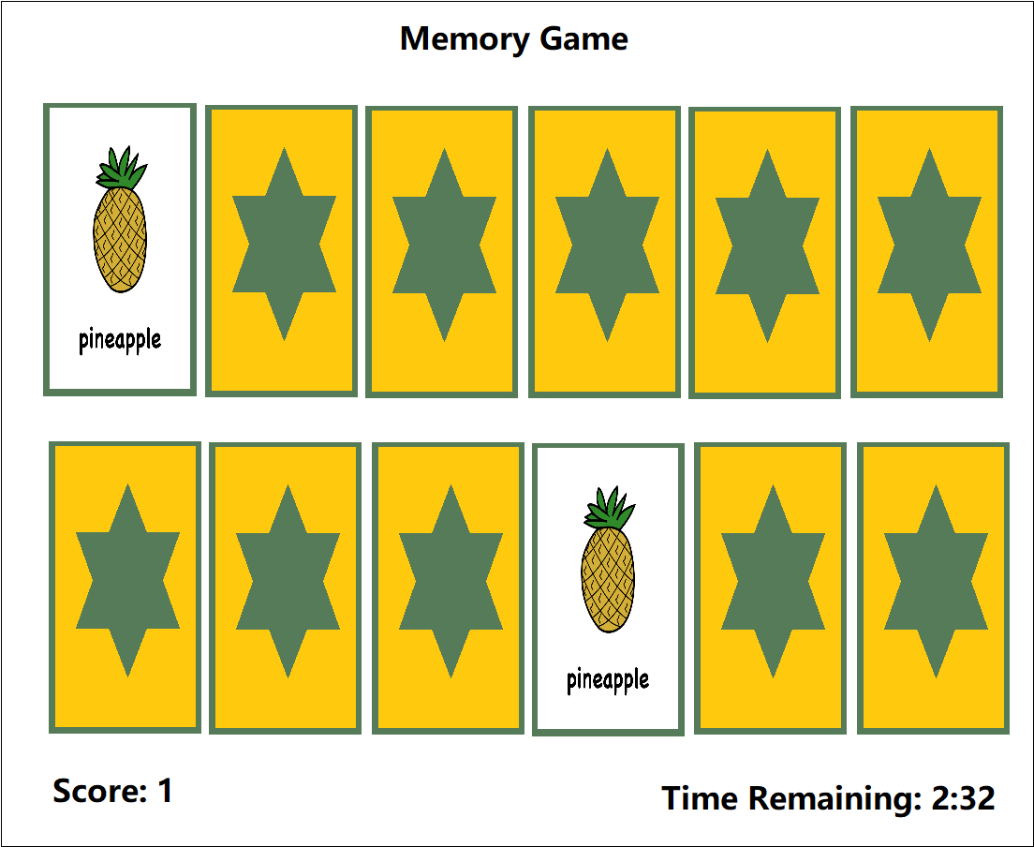

## Tools And technology:

The software required for this project will be Unity3d, Microsoft Visual Studio, Gimp photo manipulation suite. All this software is license-free for non-commercial use and so is acceptable to use for this project.

The hardware required for our group is a computer capable of running Unity3d and Microsoft Visual Studio, a microphone for recording audio and an internet connection so that we can collaborate online.

## Skills Required:

Our team will need to develop many skills to complete this project.

* programming skills to create the software in Unity3D
* graphic design skills to create the flashcards and backgrounds in Gimp or another suitable image manipulation software.
* Technical writing skills to create build documentation
* Creative writing skills to make clear, engaging instructions for users
* Liaison skills to engage consultants to work on making the game multi-lingual
* Video editing skills for presentation purposes,
* basic audio editing skills to create sounds for the flashcards and repeating background music
* project management skills to plan and manage the build
* leadership skills to help us stay focused and on task

## Outcome:

The outcome of this project will be the creation of a flashcard system to help children learn basic English words. The application will be a small but workable product that our team would be able to market on a standalone website or put on app stores.

Users will be able to add their own flashcards. This will empower the end-user to customise the app for use in ways that fit their particular ESL curriculum.

We hope that the software will be available for remote communities who don’t have high-end technology or qualified teachers to teach English.

[1]C. Taylor, "People around the world still think English is the most valuable language to learn, study shows", *CNBC*, 2020. [Online]. Available: https://www.cnbc.com/2019/06/28/people-still-think-english-is-the-most-valuable-language-to-learn.html. [Accessed: 08- Jan- 2020].

[2]A. Research, "English Language Learning Market to grow at 7.1% to hit $54.8 billion by 2025 – Insights on Recent Trends, Size, Share, Growth Opportunities, Key Developments and Future Outlook: Adroit Market Research", *GlobeNewswire News Room*, 2020. [Online]. Available: https://www.globenewswire.com/news-release/2019/07/26/1892347/0/en/English-Language-Learning-Market-to-grow-at-7-1-to-hit-54-8-billion-by-2025-Insights-on-Recent-Trends-Size-Share-Growth-Opportunities-Key-Developments-and-Future-Outlook-Adroit-Mar.html. [Accessed: 08- Jan- 2020].

[3]T. News, "Vietnam lacks teachers to achieve language targets", *Thepienews.com*, 2020. [Online]. Available: https://thepienews.com/news/vietnam-teachers-language-targets/. [Accessed: 08- Jan- 2020].